**Final Project- Pen Knife**

Michael Frajman- 1631231

Technical Drawing- 420-LCV-05 gr.1

Mr. Robert Vincent

May 16th, 2018

**Description of Parts & Subassemblies:**

**Part 1- Toothpick:**

1. Create a sketch resembling the one below:

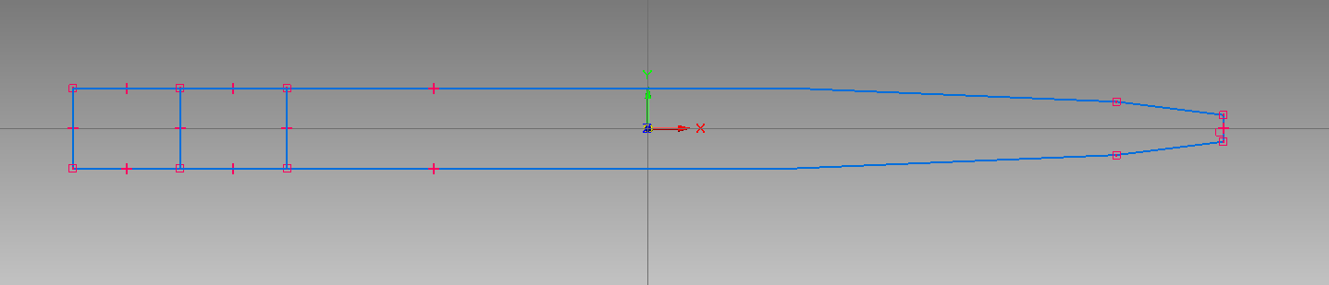

1. Extrude the outer perimeter 1mm downward, extrude the left-most rectangle upward by 1mm and extrude the second rectangle upward by 0.25mm
2. Round the left-most top edge by 2mm, chamfer the rightmost top corner with a double setback of 4mm by 0.5mm

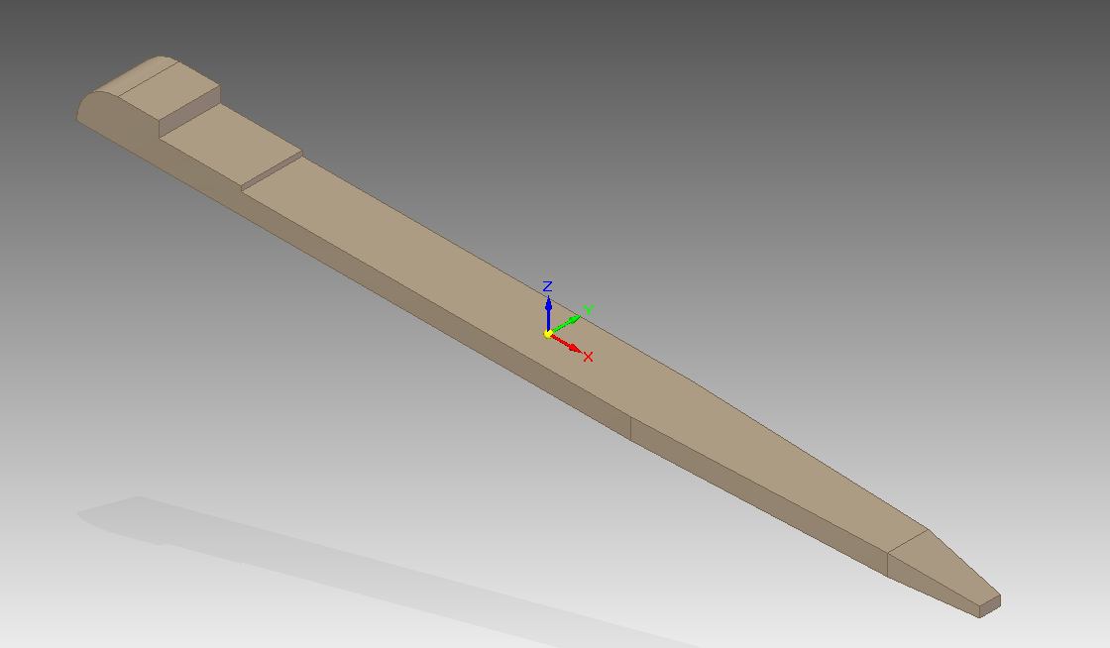

**Part 2- Front plate**

1. Create a rectangle by centre of 46mm by 12 mm, create arcs by tangent on both sides of the rectangle, each of radius 6mm, extrude this shape downward by 2mm and round the perimeter by 2mm

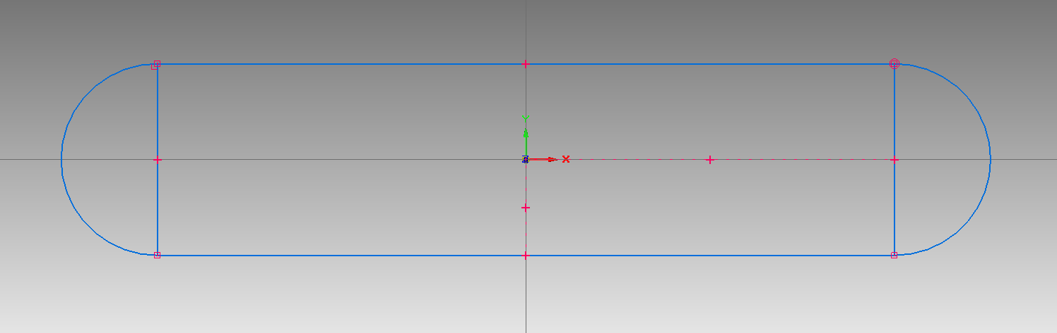

1. Create a roughly 4mm by 3mm hole on one end of this shape, cut it all the way through the object

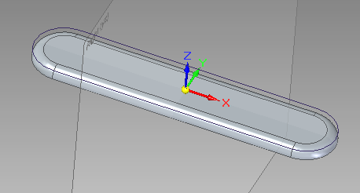

1. Create a 45mm by 3mm rectangle adjacent to the rectangle in step 2 and extrude it 1.25mm into the object
2. Create four 2mm diameter circles along the meeting point between the rectangle and arcs from step 1, put each at a point that is ½ the radius of the tangent arc, (cut each of these 1.75mm into the object), on the end opposite the step 2 create a circle of 3mm at ½ the radius of the tangent arc (cut this 1mm into the object)

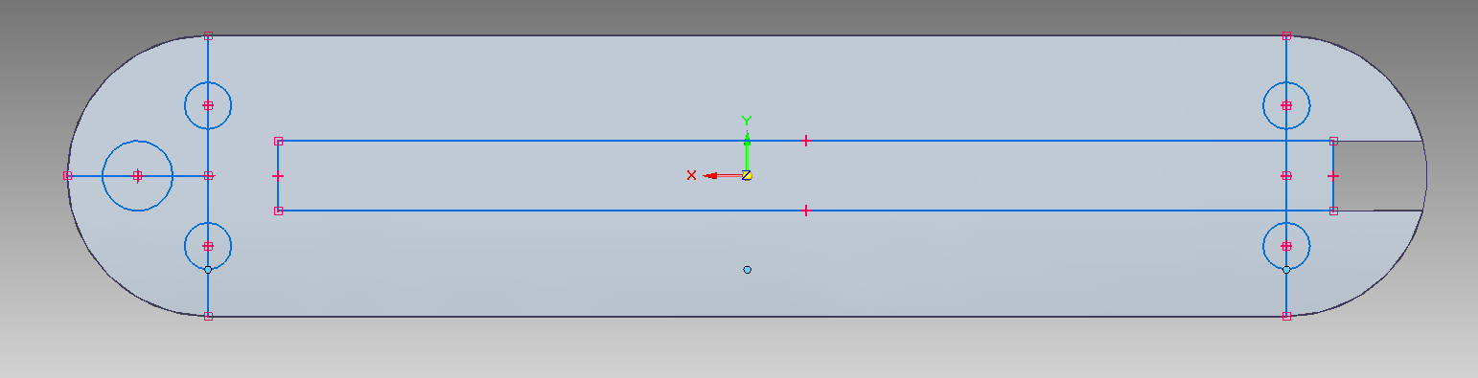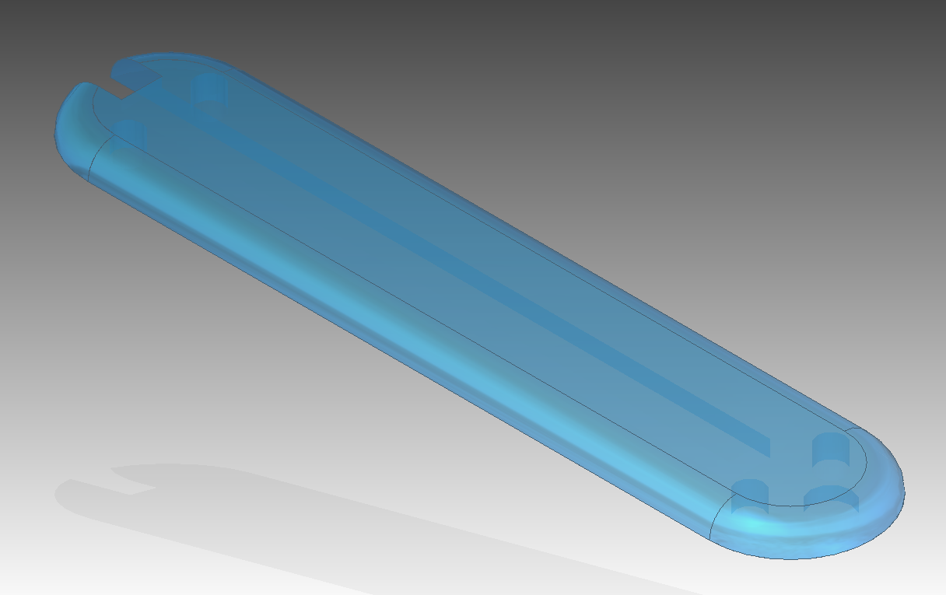

**Part 3- Back plate**

1. Same as front plate but the receptacle for tweezers is 1.45mm high instead of 1.25mm which is meant to fit the toothpick

**Part 4- Metal plate (first layer)**

1. Create a rectangle by centre of 46mm by 12 mm, create arcs by tangent on both sides of the rectangle, each of radius 6mm, extrude this shape downward by 0.5mm
2. Create a 32mm by 3mm rectangle 17mm from the left most point of the shape in step 1, cut this rectangle though the part.

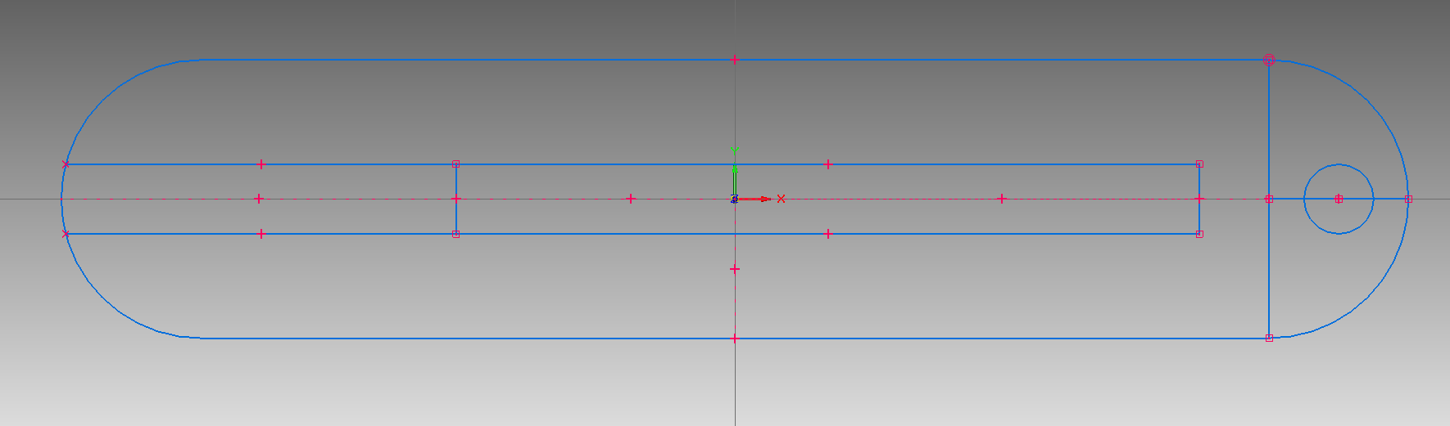

1. Create four 2mm diameter circles along the meeting point between the rectangle and arcs from step 1, put each at a point that is ½ the radius of the tangent arc, (cut each of these through the object), on right most end create a circle of 3mm at ½ the radius of the tangent arc (extrude this 1mm up from the object)

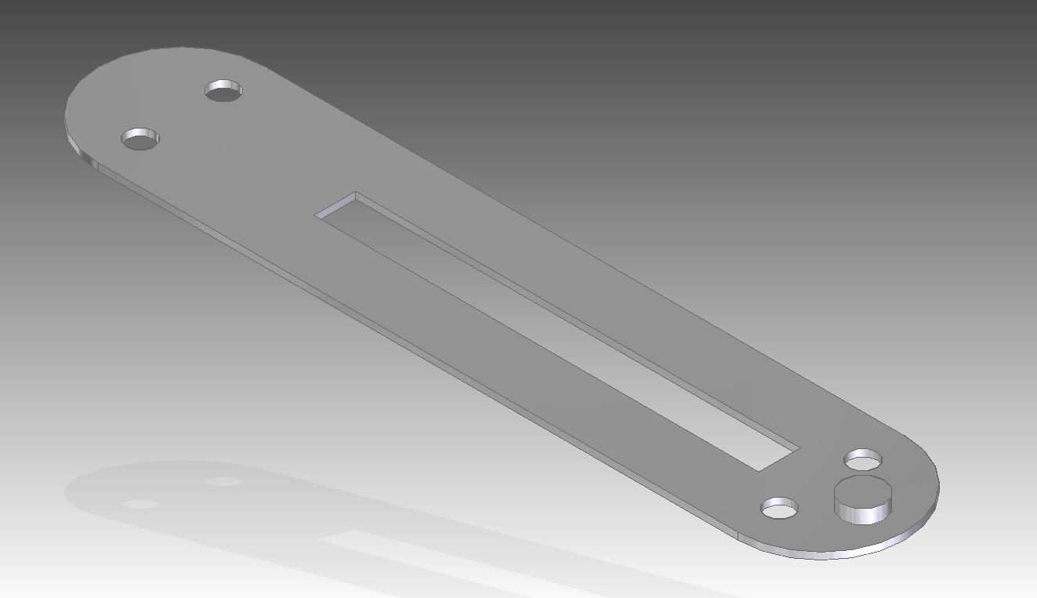

**Part 5- Fasteners**

1. Create a circle of 2mm diameter and extrude it 6.5mm

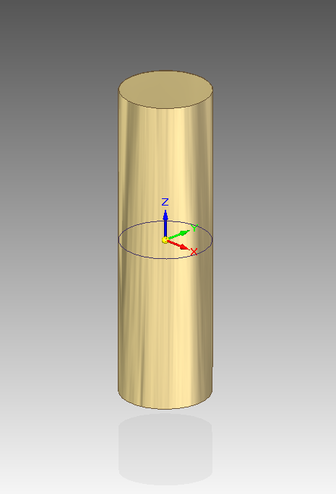

**Part 6- Nail File**

1. Create a sketch resembling the one below:

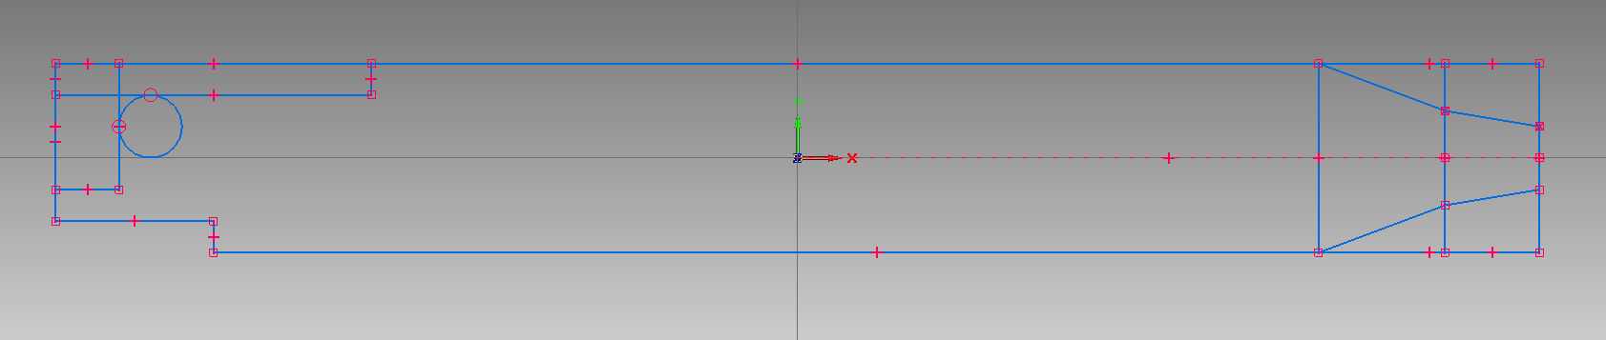

1. Extrude 1mm down and cut circle out as hole all way through
2. Create 5mm by 28mm rectangle on top surface of extruded part (extrude it 0.05mm downward)
3. Round the edges on right all by 10mm radii
4. On bottom side chamfer fare right y 3mm by 0.5mm
5. Round far right side corners 1mm, for small notch round 0.25mm
6. Round all exterior edges by 0.05mm
7. To create the notch for fingernail on bottom side, create a rectangle of 11mm by 0.75 mm that is 0.75mm lower that side, create a new plane 0.5mm into the interior of the part, create a rectangle 11mm by 0.08mm on this plain, create a lofted cut between these two rectangles and round all edges by 0.05mm

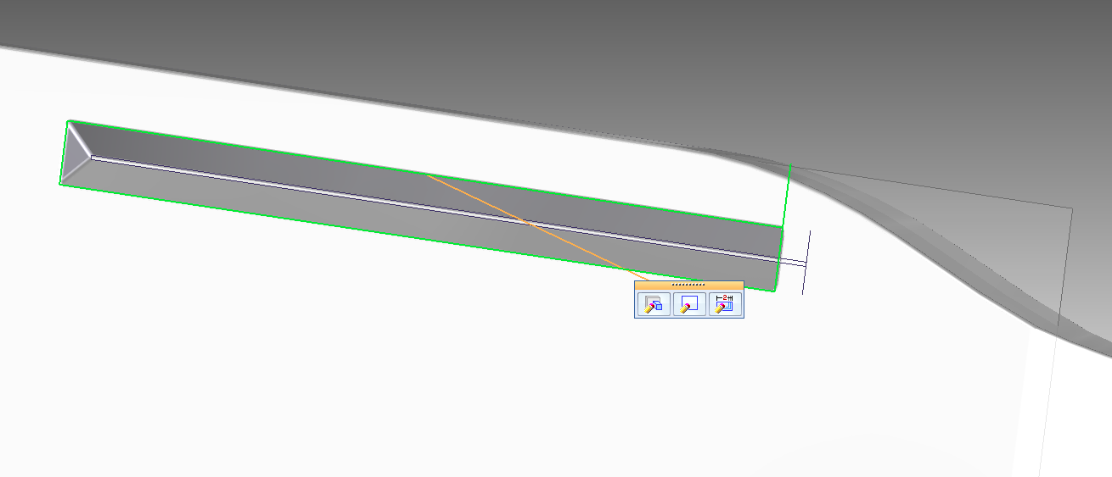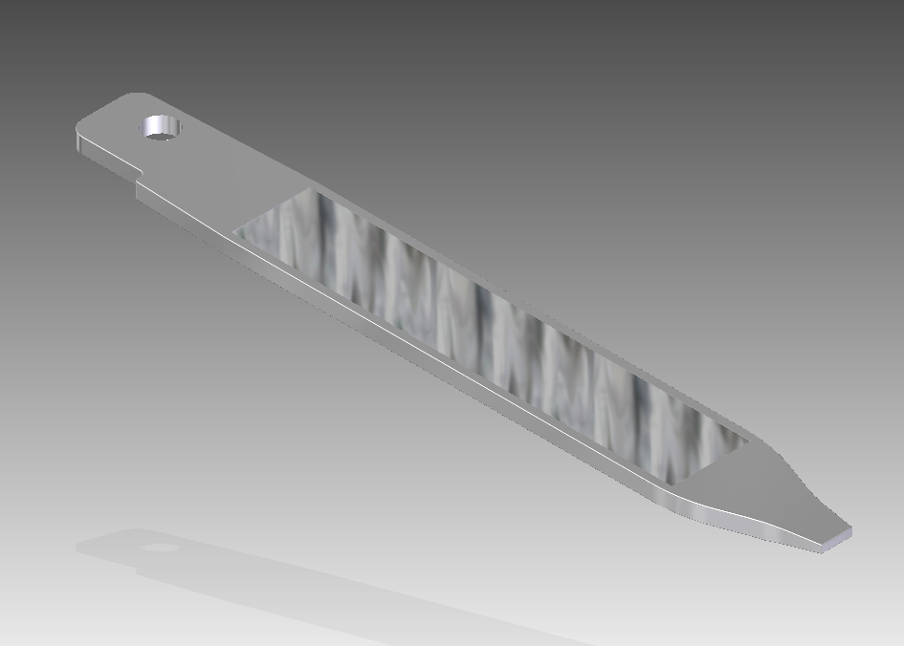

**Part 7- Knife**

1. Create a sketch resembling the one below:

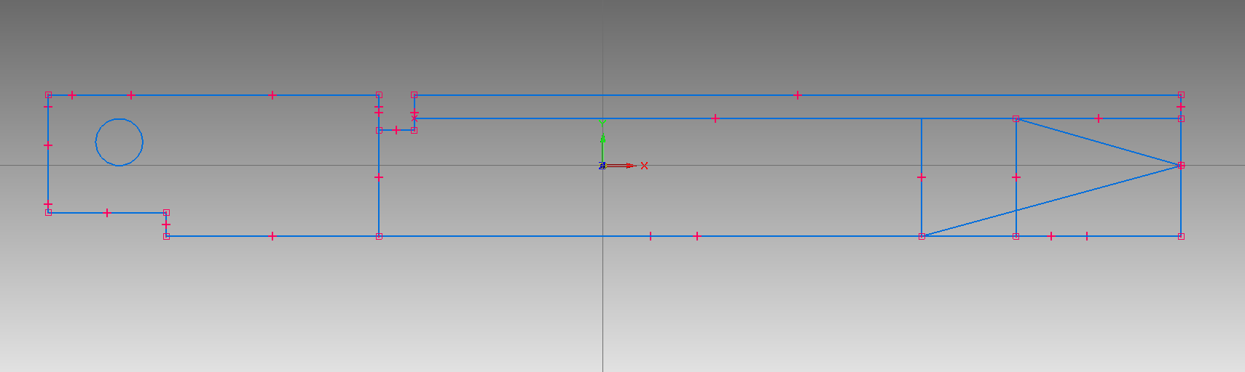

1. Extrude symmetrically by 1mm, cut the hole though object
2. In right plane, draw a 4.5mm by 0.4mm legged triangle on both sides of the front of the blade, cut them up to the line from step 2 and through the tip of blade

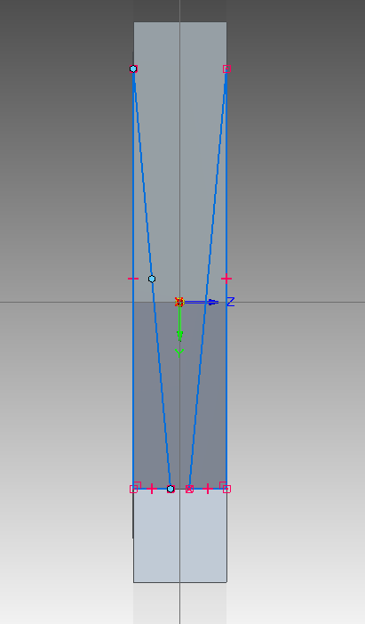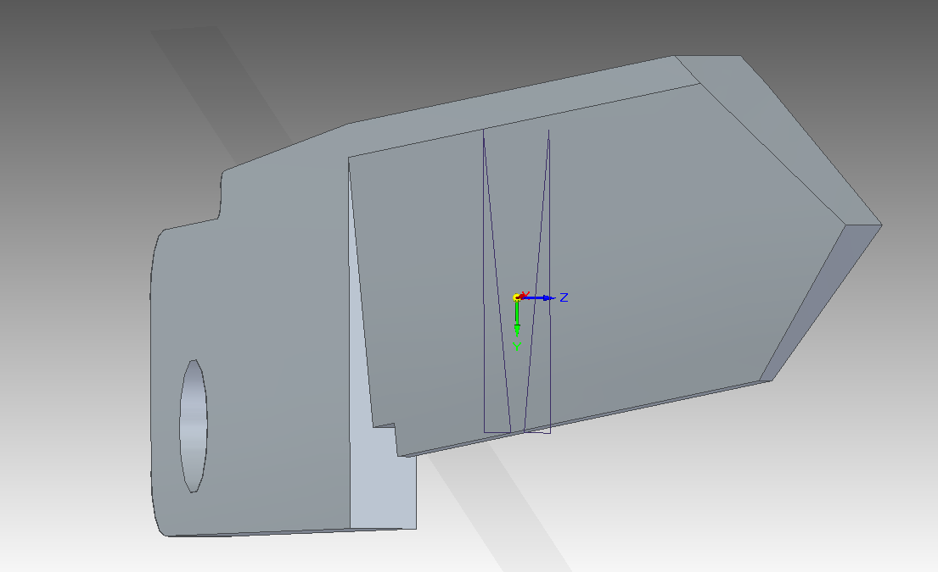

1. Round left most edges of fastening end, the pockets of the notch and the non cutting edges the same dimensions as the nail file.
2. Round the top and bottom rightmost edges of the bade by 30mm each
3. Round the edges in the small notch by 0.5mm each, chamfer the edge closest to the blade by double setback 0.75mm by 1mm
4. Chamfer the first two portions of the blade on both sides by equal setback by 0.1mm, chamfer the furthest section by equal setback 0.28mm
5. Create the notch in virtually the same fashion as the nail file, the location will be slightly different at line one from step 1 and 0.5mm below top of blade

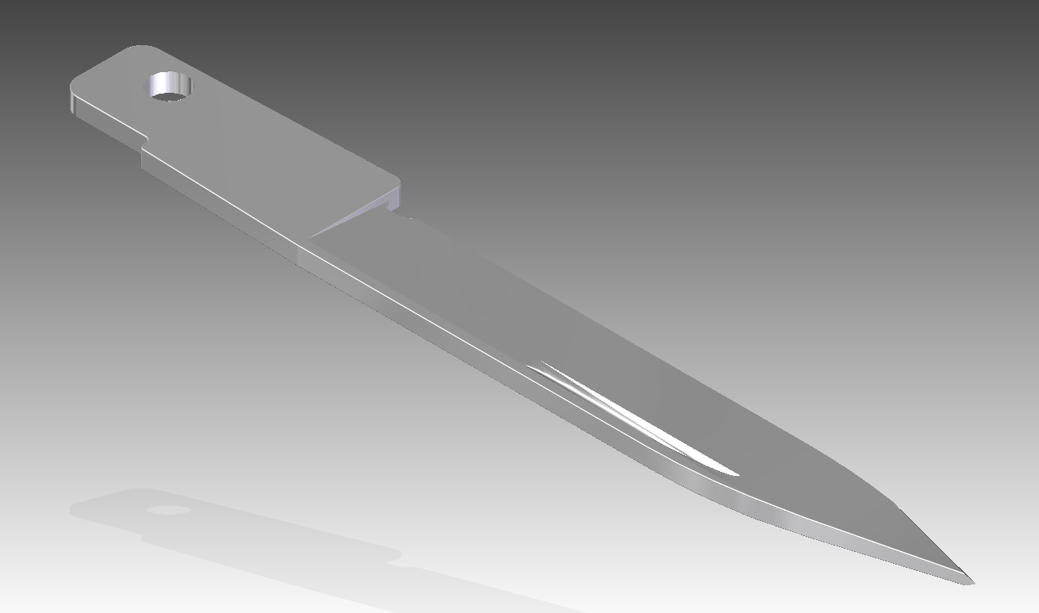

**Part 8- Interior Layer-scissor side (type 1)**

1. Create a sketch resembling the green outline below:

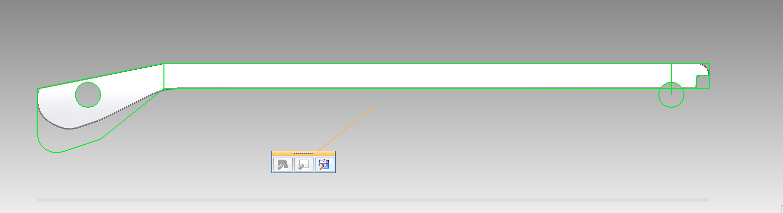

1. Extrude 1mm down, cut the circle
2. Round edges of big curve
3. Round other edges, like those around the long end divots
4. Make semi circle cut out on one end to fit around second fastener
5. Cut small square divot to fit scissors
6. Round outer side edges

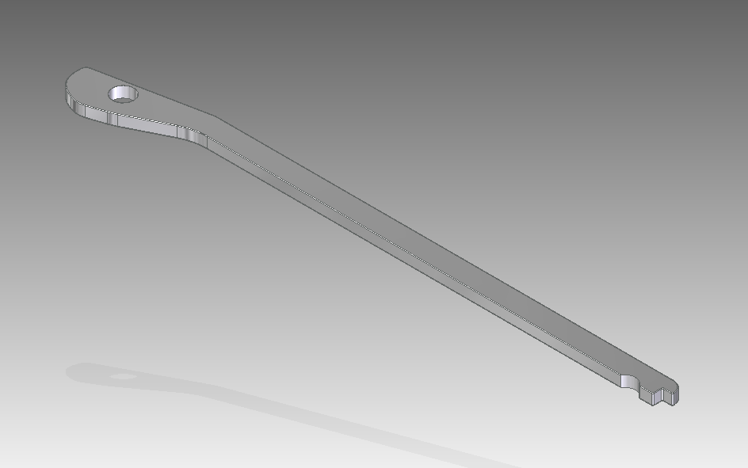

**Part 9- Interior Layer-knife side (type 2)**

1. Virtually identical initial sketching as the scissor side/type 1 but with part of the end length cut, it should resemble the outline below:

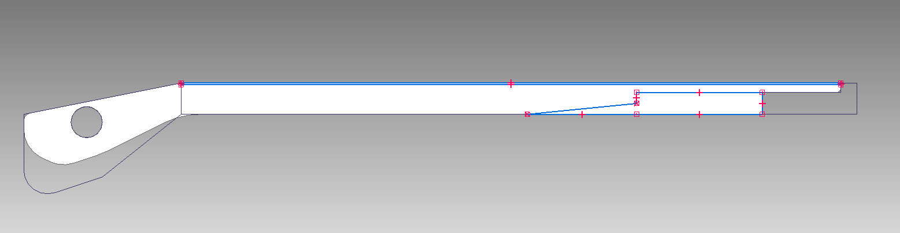

1. Cut spaces for file and knife to fit
2. Slim the top side by a few tenths of millimetres to fit next to interior layer type 1’s in the assembly

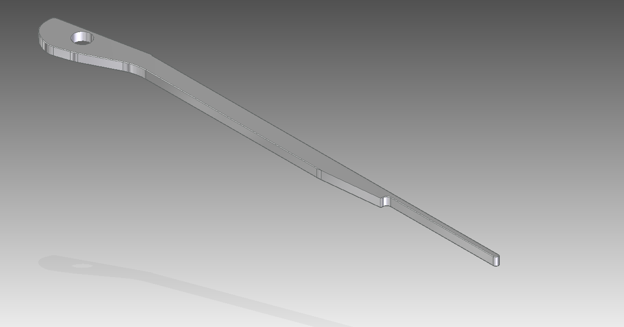

**Subassembly 1- Tweezers:**

**Part 1- Metal prongs**

1. Create a sketch that resembles the one depicted below, the sketch is created as if it were a side view

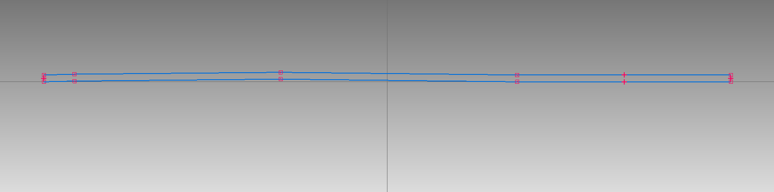

1. After the sketch, symmetrically extrude by 3mm
2. Two holes on flat right hand area of extruded surface and cut them through

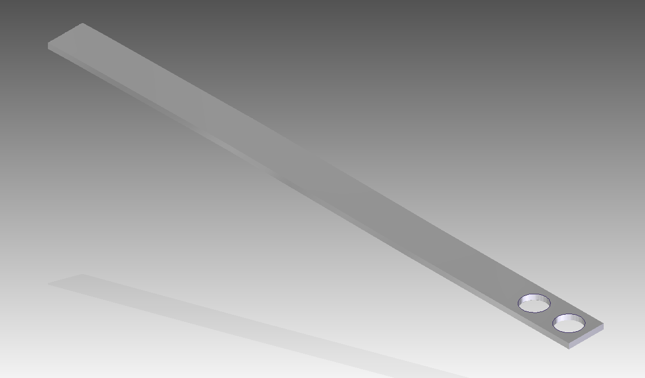

**Part 2- Plastic head**

1. The shape is modified from the toothpick head and can therefore be taken from the other part by removing the long portion of the body with a cut
2. Remove a 0.9mm by 6mm space from under head by cutting

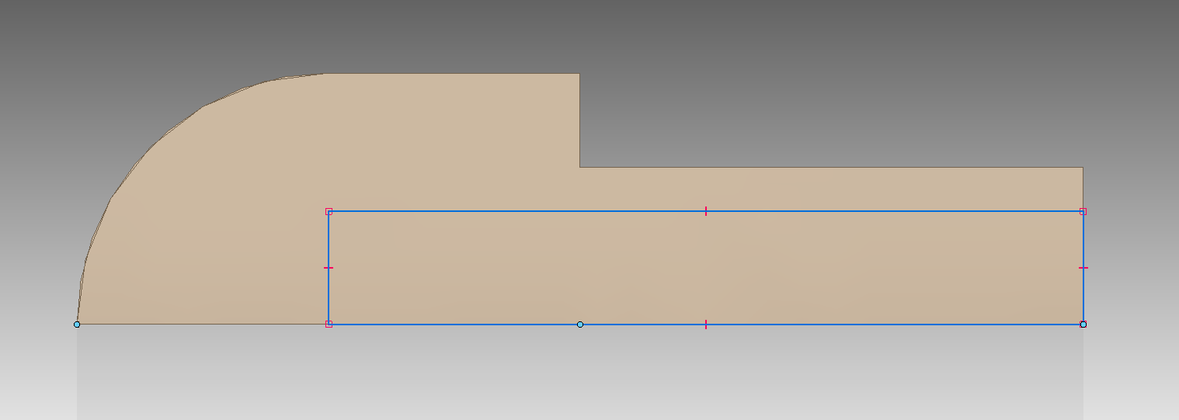

1. Create two circular protrusions to fit holes in metal prongs by sketching on the underside and extruding

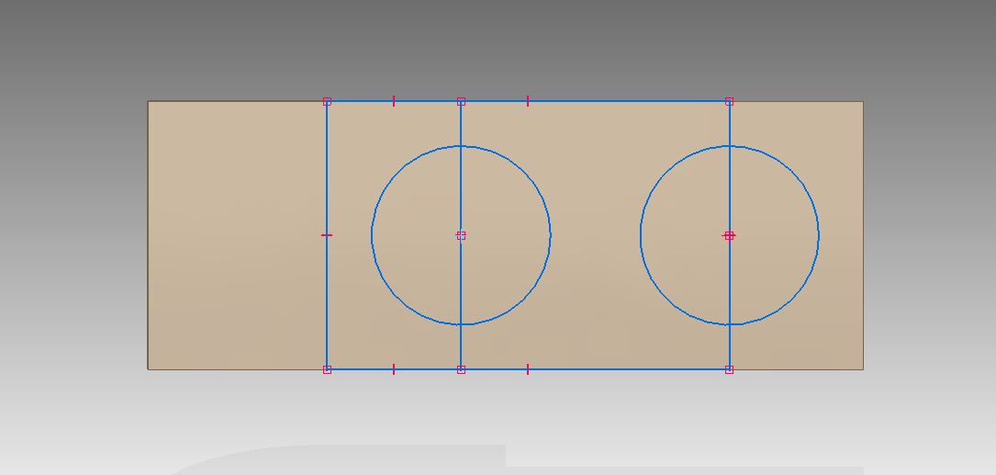

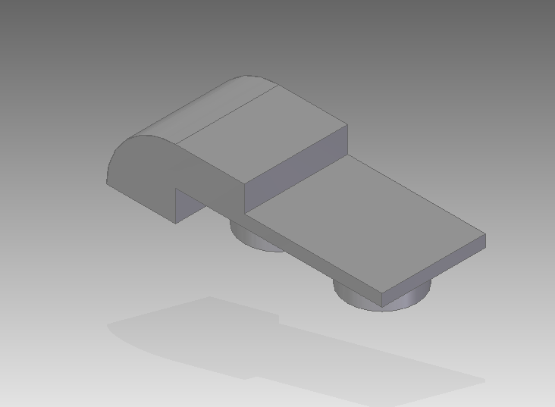

**Final tweezer subassembly:**

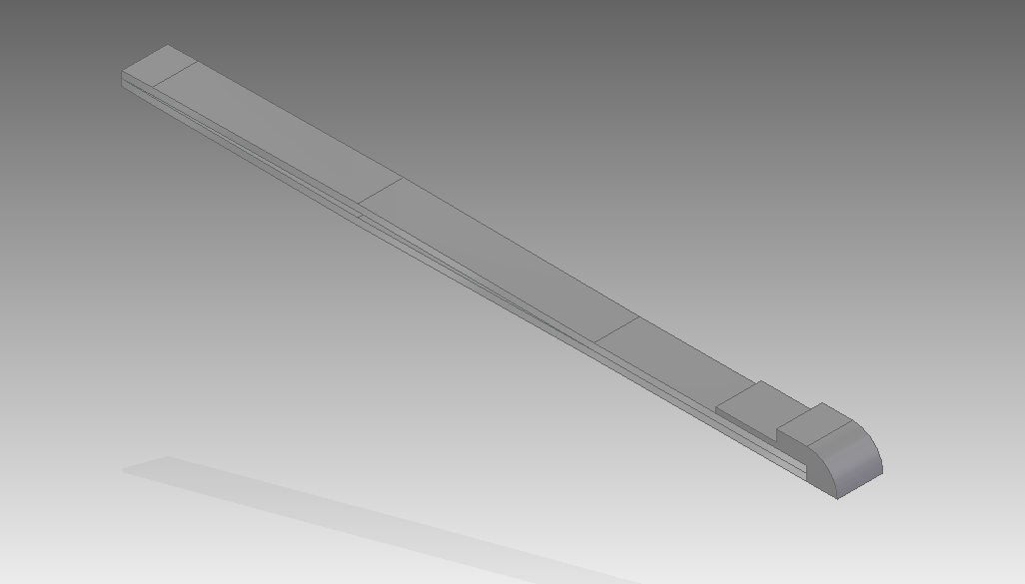

**Subassembly 2-Scissors:**

**Part 1- Fastening/scissor bolt**

1. 3mm circle extruded 1mm, with 2mm circle on other side also extruded 1mm in opposite direction
2. Round outer edges

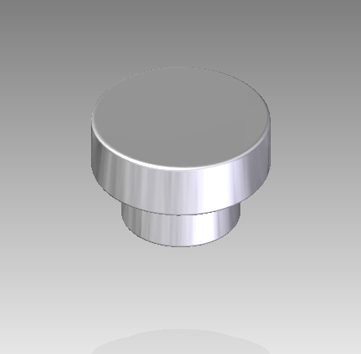

**Part 2-** **Front/long blade**

1. Create a sketch resembling the one below:

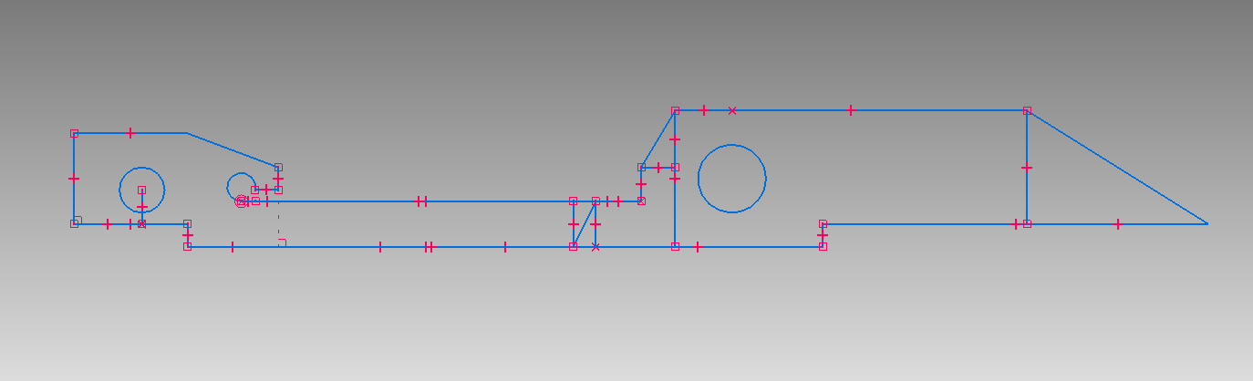

1. Extrude the section on the left of the diagonal by 2mm, and the one on the right by 1mm and cut hole
2. Similar to the knife, sketch triangle on a plane perpendicular to the blade and cut it through, chamfer the bottom to give it more of a sharp look
3. Round appropriate edges
4. Cut a hole in the center portion for later assembly with the fastening bolt
5. Create the proper rounding on the blade end with a sketch resembling the one below, the circle should be roughly 30mm in radius

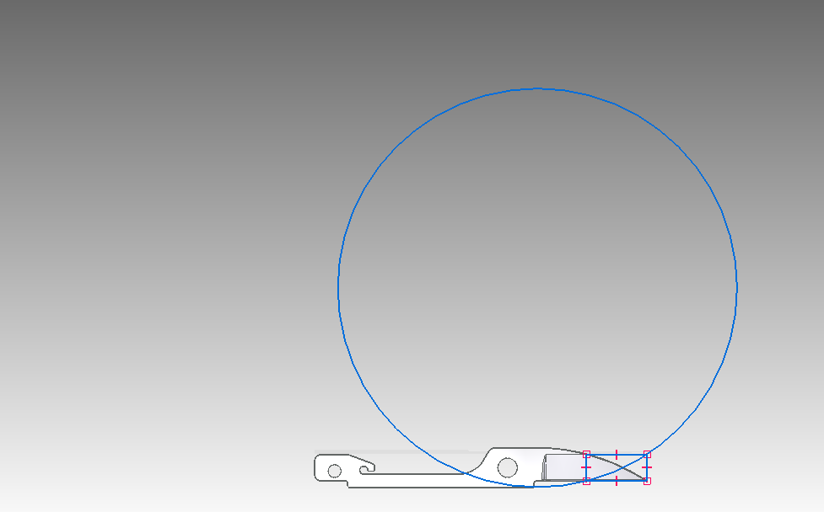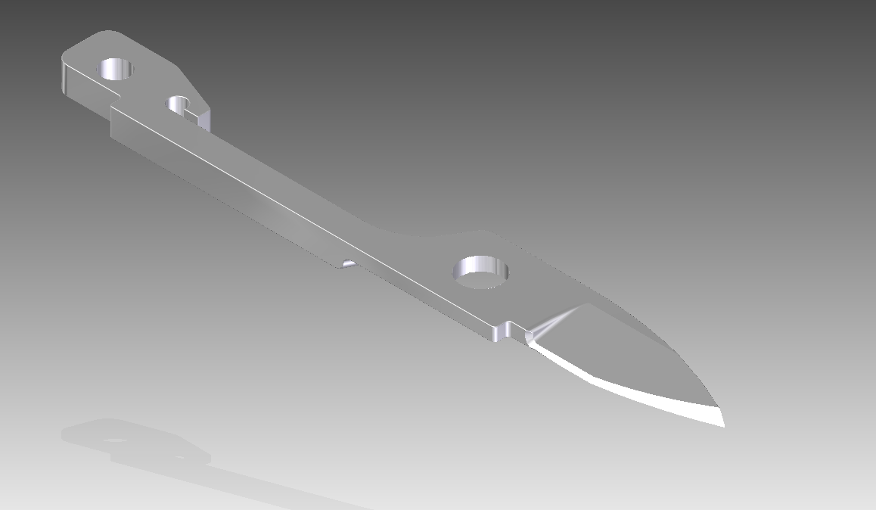

**Part 3- Back/short blade**

1. Uses the same general shape as the front blade and can be made out of the same part file however a portion of the handle (left side) is cut
2. Also on the handle side the extrusion of 2mm needs be to the opposite side, this can be done with a combination of cutting and extruding
3. Round the end of the handle evenly
4. The hole in the center for the fastening bolt to a 2mm cut
5. Add fingernail divot back side of the blade end in a similar fashion as was done with the knife and nail file

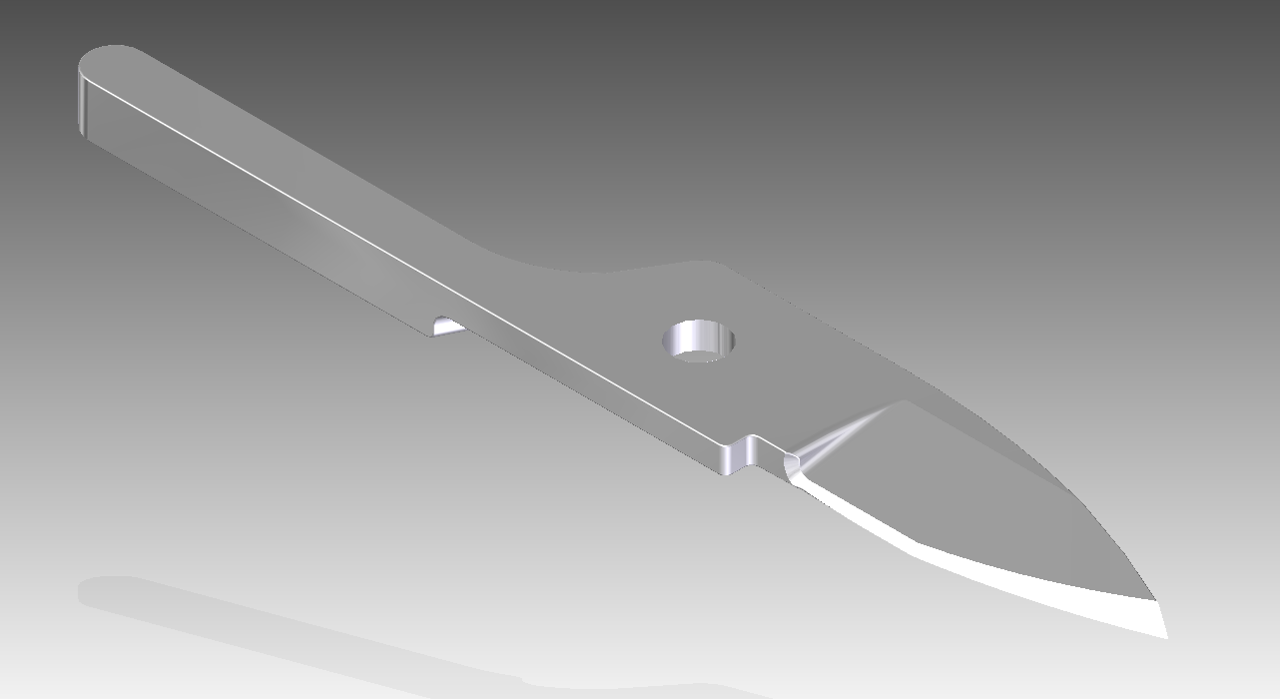

**Final scissor assembly:**

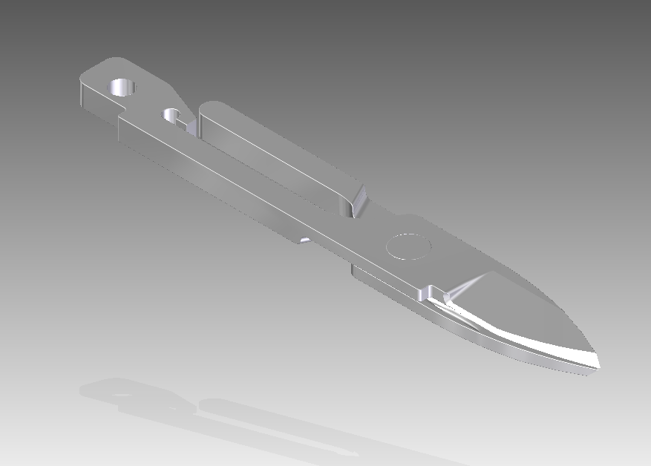

**Final Assembly:**

**Final Assembly:**

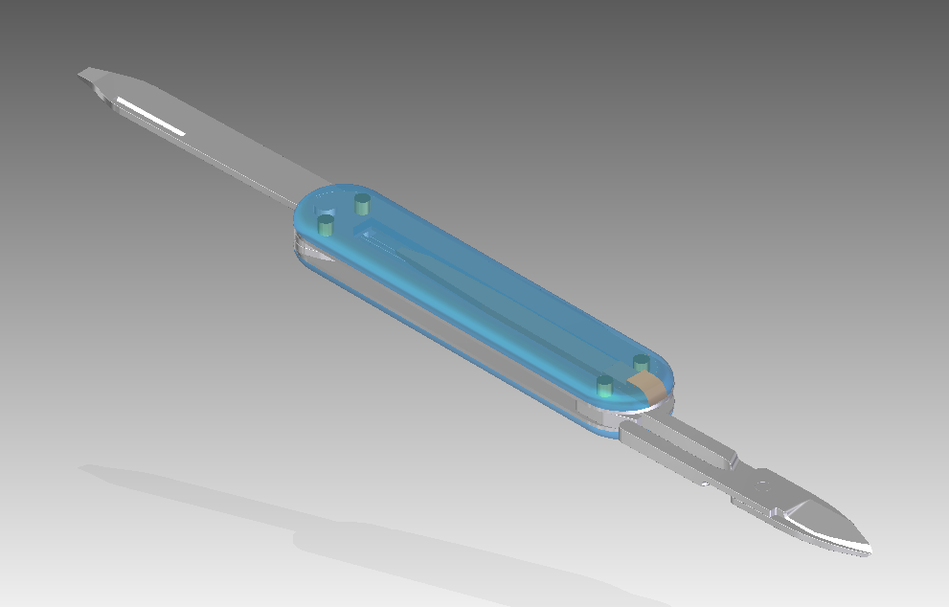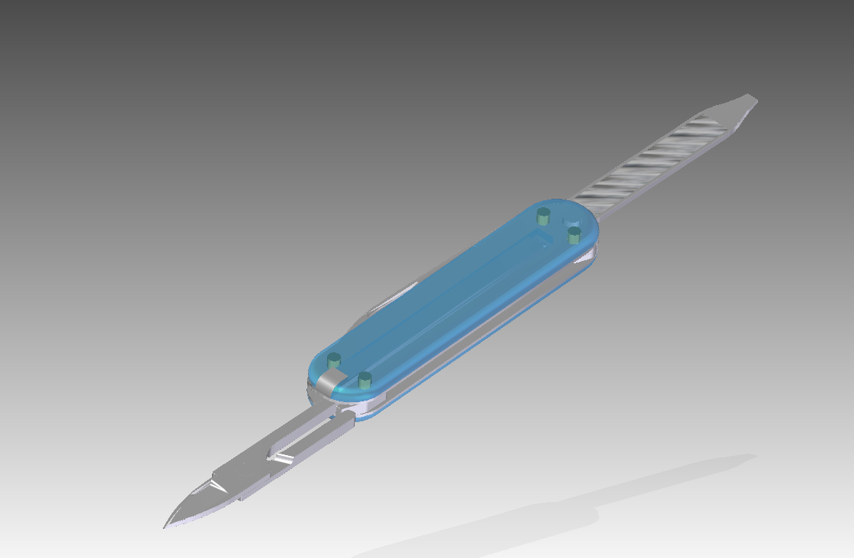

**Exploded View:**

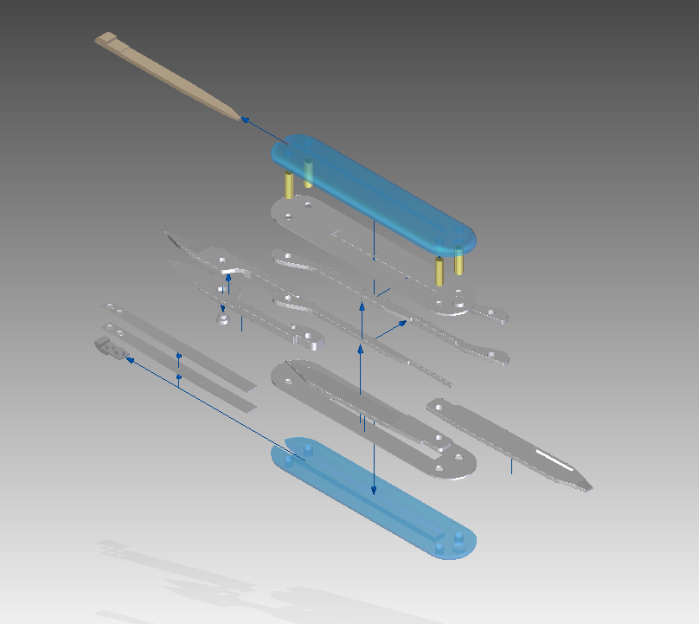

**Real Object:**

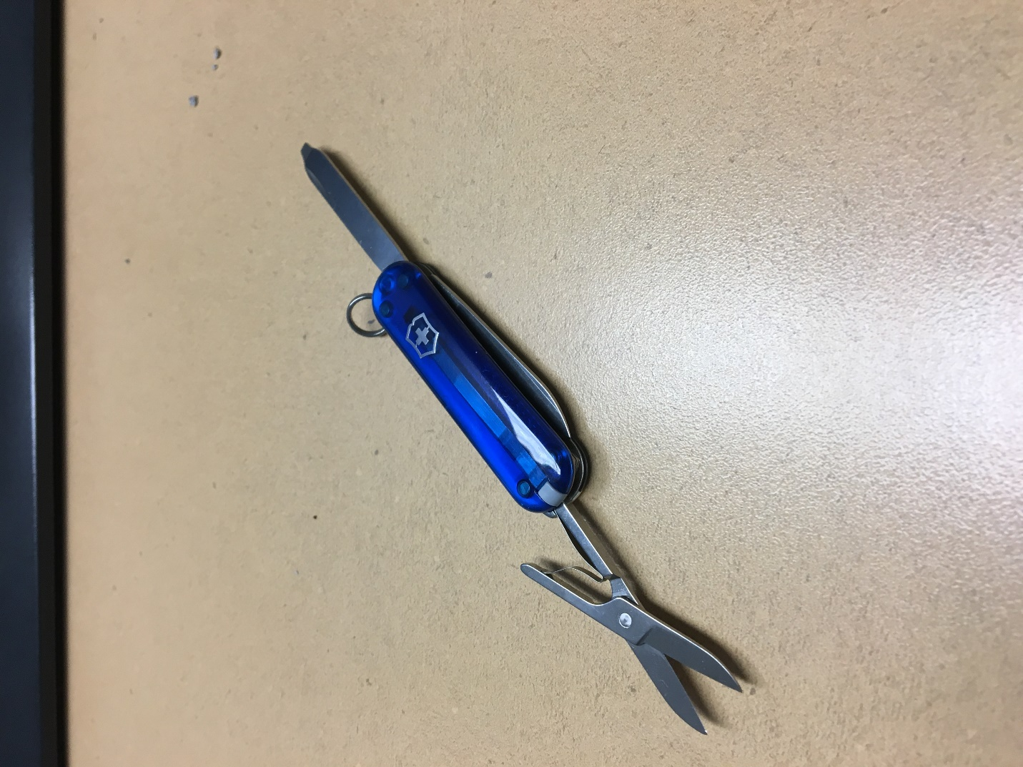

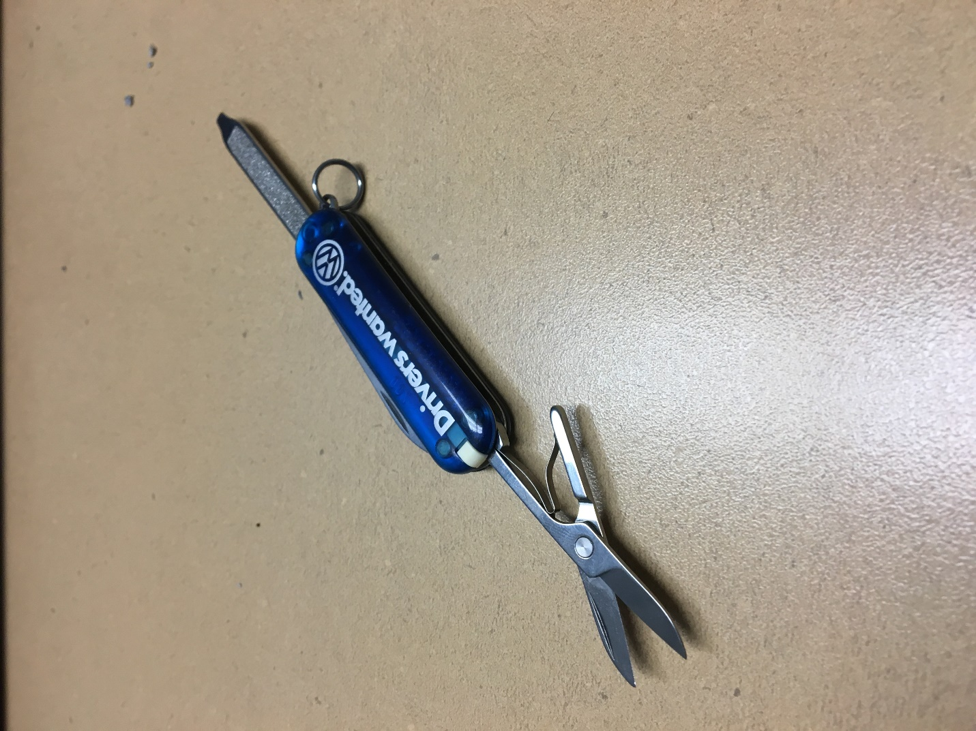

**Encountered Difficulties:**

Of all the parts that were modelled, the two types of interior layers proved the most challenging to recreate. Since it was difficult to determine measurements, many of the dimensions used were initially approximated. Some of these dimensions proved incompatible when the final assembly was being put together and the interior layer part needed to be constantly modified. At one point the part was “split in two” and a second version, type 2, was created in order to better fit the knife side. This is also the reason why these parts have inconsistent names between their file and title as interior layer type 1 was originally meant for the knife side but in the end was used only on the scissor side. Instead interior layer type 2 was created for the knife side as mentioned above. Other than these interior layer parts, there were minor adjustments needed for other parts during assembly but they were no where near as drastic. For example, the bolt fasteners needed to be re-extruded to be a couple millimetres shorter.

Recreating the knife and scissor blades proved a challenge as well and were improvised using cutting and chamfering. Triangles would be sketched in a separate plane and cut the length of the blade to get the general shape. Multiple chamfers would then be applied, sometimes on top of each other, in order to give the blades a sharper look. As a result, some of the blades look a little lop sided and, as described on the drafts themselves, it was close to impossible to properly or accurately dimension the chamfers in the drafts.

In the interest of time and simplicity, some parts like the springy piece of metal placed between the scissor blades (visible in the photos of the real object) were omitted. The aforementioned part in particular was incredibly difficult to recreate with solid modelling do to its flowing shape and was omitted due to time constraints. In general, every part has its more complex dimensions, especially curves approximated.